5 Themes of Geography

- Location
- Place
- Region
- Movement
- Human Environment

- Location has two parts: Absolut and Relative
Absolute means a specific location such as the United States.

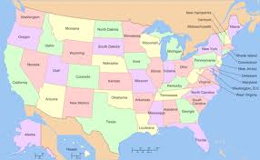

Relative is something next door, down the street or another location like the post office.
